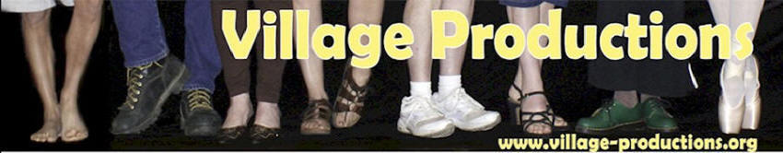

**Winter 2020** – **January 5 through March 21**

Village Productions is located at 16 East State Street, Amesville, OH 45711.

**To learn more, visit www.village-productions.org or call 740-777-4621**. Check website for latest updates and cancellations!

**­­Monday**

**Hatha Yoga - Mondays, 9:00-10:15 am**   
Drawing on the Integral Yoga practice as taught by Swami Satchitananda, George will present a beginners level class which will include chanting; asana (postures); pranayama (breathing exercises); yoga nidra (deep relaxation); and a brief meditation. George strives to remain true to the Integral Yoga tradition. Additional yoga poses or series of poses may be incorporated when appropriate.  Come with an open mind, leave with an open heart. **Instructor: George Kridler**

**Tuesday**

**Pilates: Mixed Level -** **Tuesdays, 5:30-6:30 pm**

Fee is $88, paid in full for a session. Drop-ins: $10.

This class is best suited for those with some previous Pilates experience. This class will include classical as well as adapted mat exercises. Some classes will include Ring exercises and posture exercises along the wall. Exercises will be modified to accommodate specific conditions as needed. Everyone is encouraged to work at their personal level of challenge!

**Instructor: Kate Blyth**

**­­**

**Wednesday**

**Zumba**® **- Wednesdays, 5:30-6:30 pm**

Each Zumba® class is designed to bring people together to sweat but most important, have FUN!! Zumba is a total workout, combining all elements of fitness-cardio, muscle conditioning, balance and flexibility, boosted energy and a serious dose of awesome each time you leave class. It is perfect for everybody and “every body”. Come! invite your friends to have fun and burn calories with the best Latin rhythms!

**Instructor: Ramiro Malgor**

**Schedule accurate as of printing.**

**Thursday**

**Embodied Movement - Thursdays, 9:00-10:00 am**

Mindful exploration of yoga asanas along with a variety of other creative movement to build strength, increase flexibility and create greater mobility. **Instructor: Stephanie Robinson**

**Restorative Yoga - Thursdays, 5:30 - 6:45 pm**  
This restorative class offers a unique opportunity for your body to completely relax. By totally supporting the body with bolsters, blocks, and blankets your nervous system sends and receives fewer messages and thus becomes quieter and calmer. You may come into greater harmony with your body as layers of tension melt away. This class is open to all, with no previous yoga experience necessary.  
**Instructor: George Kridler**

**Saturday**

**Yinyasa Flow with Nicole or Shei - Saturdays, 9:00-10:00 am**

A gentle mix of Yin Yoga and Vinyasa to start and invigorate your weekend. Open to all levels, this class explores ways to increase flexibility, foster resilience, and build strength, in body, spirit, and mind.

**Instructor: Nicole or Shei (check calendar)**

**Sunday**

**Meditation Circle - Sundays, 9:15-10:30 am**

**Gathering at 9:15; program at 9:30**

Meditation practices from a variety of traditions, as well as inspirational readings and discussion. Participants will be invited to share their own personally enriching practices and readings. FREE, but donations to Village Productions appreciated.

**Host: Drake Chamberlin**

**Amesville Community Singers – Sundays, 5:00-6:15 pm**

Do you like to sing? Come join us in learning choral arrangements and sing-alongs. Together we can strengthen musical skills of all levels, and alleviate the stress of the day through the therapeutic benefits of group singing. $25 class fee for non-members.

**Director: E J Waskiewicz**